Appsters Industry Page Layout
MUSIC
Laid out fold by fold against www.appsters.io/industry
 | DETAIL
Slug | music-app-development-company
Meta Title | Music App Development Company | Build Your Streaming App
Meta Description | Launch a music streaming, artist or fan engagement app with zero buffering playback and smart discovery. Hire Appsters music app developers now.
Layout Source | www.appsters.io/industry
Live Folds | 23
New Blocks Required | 3
FOLD 1: Hero Banner
Hero Banner
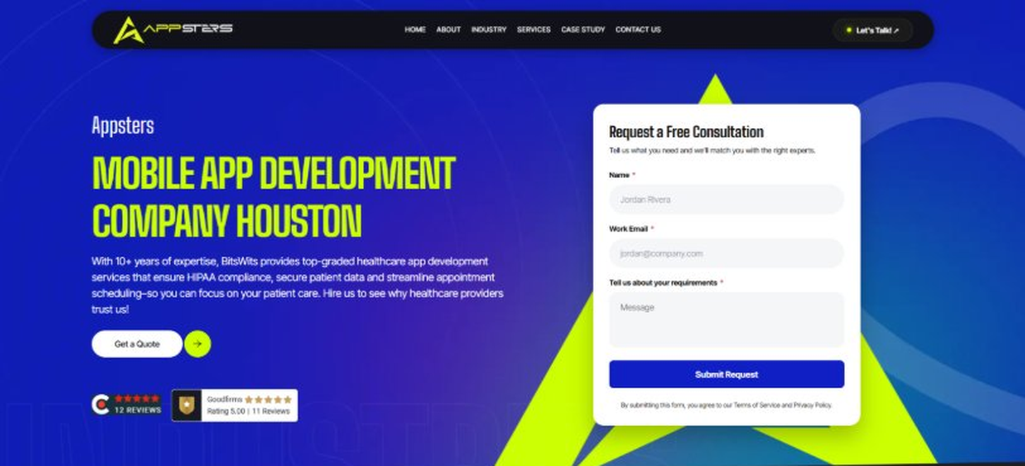
Current live page, www.appsters.io/industry
 | DETAIL
Status | New copy applied
Build Notes | Live block holds H1, sub copy, a Get a Quote button and the Request a Free Consultation form. New copy supplies the H1 and sub copy only.
QA Flag | Live hero copy currently names BitsWits and describes healthcare services. Leftover copy from another build, replace it with the new copy below.
Copy For This Fold
PAGE ELEMENT | COPY (WORD FOR WORD)
H1 (Page Heading) | A Music App Development Company Building Platforms That Keep Fans Streaming
Body Copy | Streaming numbers move fast, and fan loyalty moves faster. As a music app development company, Appsters builds Music apps that turn casual listeners into dedicated fans through smart discovery, rock-solid playback, and real artist connection. We build platforms for labels, independent artists, and streaming startups that need to compete with players many times their size.
FOLD 2: Marquee Strip
Marquee Strip: Turn Your Wildest Ideas Into Powerful Digital Products
Current live page, www.appsters.io/industry
 | DETAIL
Status | No copy change
Build Notes | No new copy in the source document for this fold. Keep the live block exactly as it is.
FOLD 3: Stats Counter
Stats Counter: Work With A Local Mobile App Developer In Houston
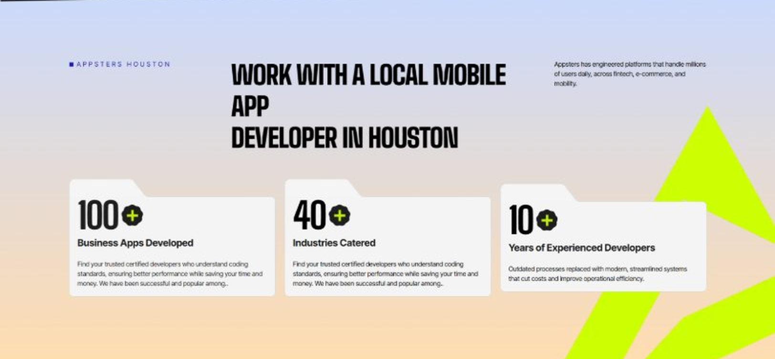
Current live page, www.appsters.io/industry
 | DETAIL
Status | New copy applied
Build Notes | Live block holds 3 counters. New copy holds 6 stats. Either widen the block to 6 or drop two.
Copy For This Fold
PAGE ELEMENT | COPY (WORD FOR WORD)
H2 (Section Heading) | Awarded For Building Music Apps That Keep Millions Listening
Body Copy | Our Music app development work has earned recognition for playback reliability, discovery design, and measurable listener retention. Appsters has been recognized for delivering platforms that stream without buffering, recommend without guessing, and stay stable through festival season traffic spikes. Every award reflects tested performance, not a demo reel.
Stat 1 Number | 40+
Stat 1 Label | Industries Served
Stat 1 Copy | Our experience spans social platforms, marketplaces, fintech, healthcare, and more, with solutions adapted to each sector's demands for security, AI, compliance, and user adoption.
Stat 2 Number | 3000+
Stat 2 Label | Apps and Solutions Delivered
Stat 2 Copy | Thousands of projects executed with an emphasis on speed, AI adoption, stability, and clear ROI across both startup and enterprise environments.
Stat 3 Number | 60+
Stat 3 Label | AI Models Deployed
Stat 3 Copy | Every model is designed for high accuracy, reliable outputs, and performance at scale for mission-critical workflows and more.
Stat 4 Number | 50,000+
Stat 4 Label | Legacy Processes Modernized
Stat 4 Copy | Outdated processes replaced with modern, streamlined systems that cut costs and improve operational efficiency.
Stat 5 Number | 250+
Stat 5 Label | Engineers and Designers
Stat 5 Copy | A global team skilled in native mobile app development, AI-driven ecosystems, cross-platform builds, and enterprise architecture.
Stat 6 Number | 95%
Stat 6 Label | Client Retention
Stat 6 Copy | Long-term partnerships built on trust, consistent delivery, and continuous optimization of live applications.
FOLD 4: Marquee Strip
Marquee Strip: Mobile App Development Services
Current live page, www.appsters.io/industry
 | DETAIL
Status | No copy change
Build Notes | No new copy in the source document for this fold. Keep the live block exactly as it is.
FOLD 5: Services Grid
Services Grid: Our Comprehensive Mobile App Development Services In Houston
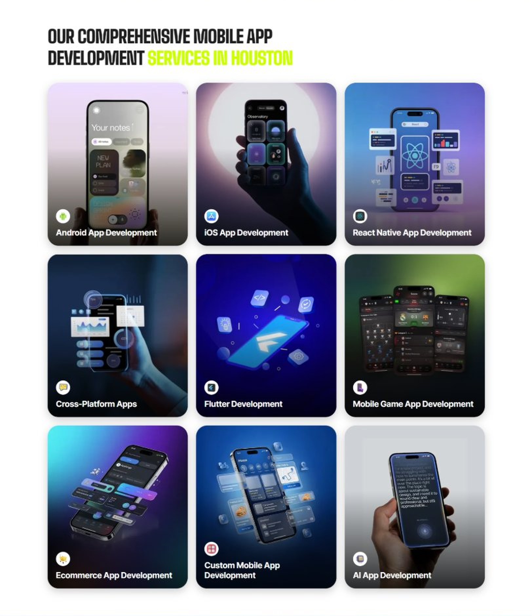
Current live page, www.appsters.io/industry
 | DETAIL
Status | New copy applied
Build Notes | Live grid holds 9 cards. New copy holds 5 services. Either trim the grid to 5 or brief four more services.
Copy For This Fold
PAGE ELEMENT | COPY (WORD FOR WORD)
H2 (Section Heading) | Music Application Development Services Built For Listeners Who Stick Around
Body Copy | Strong music platforms sit at the crossroads of licensing, discovery, and playback engineering. As a music app development company, we connect creative product thinking with technical precision. Appsters' senior developers build platforms that support gapless streaming, offline listening, and monetization tools for artists, labels, and everyday listeners. Every layer is built to hold up under real catalog size, not just a demo playlist.
Service 1 Heading | Music Finder App Development
Service 1 Copy | As Music app developers, we build discovery engines that help listeners find new artists, genres, and playlists that actually match their taste. Collaborative filtering, mood-based search, and social listening replace generic charts with recommendations people actually act on.
Service 2 Heading | Food Ordering App Development
Service 2 Copy | Live events are where music apps make real money, and our food ordering app developers know how to build in-venue ordering directly into a festival or concert app. Fans order food and drinks from their seats while the app keeps the show experience front and center.
Service 3 Heading | Food Delivery App Development
Service 3 Copy | As a food delivery app development company, we build fulfillment layers that connect vendor stalls to mobile orders at large-scale events, with live status updates so fans know exactly when to head back and pick up their order.
Service 4 Heading | Discounts App Development
Service 4 Copy | Our Music discounts app development work helps platforms reward superfans with early ticket access, merch discounts, and loyalty perks tied directly to listening history and concert attendance.
Service 5 Heading | Music Review & POS Software Development
Service 5 Copy | For venues and festivals running on our platforms, our POS software development company expertise connects ticketing, merch sales, and fan reviews into one reliable system, so promoters see real-time revenue without reconciling five different tools.
FOLD 6: Case Study CTA
Case Study CTA: HELPP
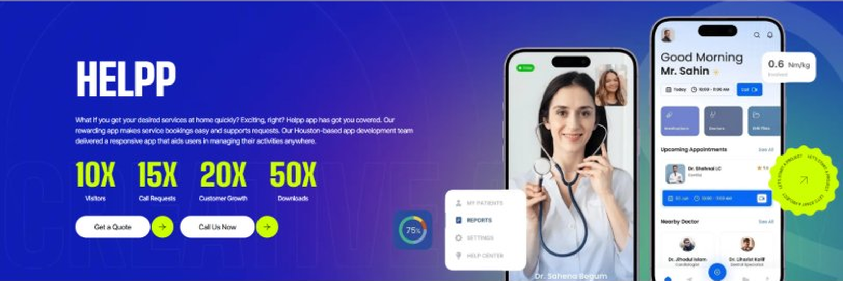
Current live page, www.appsters.io/industry
 | DETAIL
Status | New copy applied
Build Notes | Live block holds a product name, a paragraph, four metric counters and two CTA buttons. New copy supplies the heading and paragraph. Metrics still need to be supplied.
Copy For This Fold
PAGE ELEMENT | COPY (WORD FOR WORD)
H2 (Section Heading) | Music App Developers Who Build For Fans Who Actually Come Back
Body Copy | Launching a streaming app is easy. Getting listeners to open it every day is the hard part. If you're ready to build Music apps that fans stay loyal to, Appsters is the partner that gets you there. Let's talk about your catalog, your audience, and what a platform built to last actually requires.
FOLD 7: Testimonials
Testimonials: Real Stories From People Who Wanted What’s Next
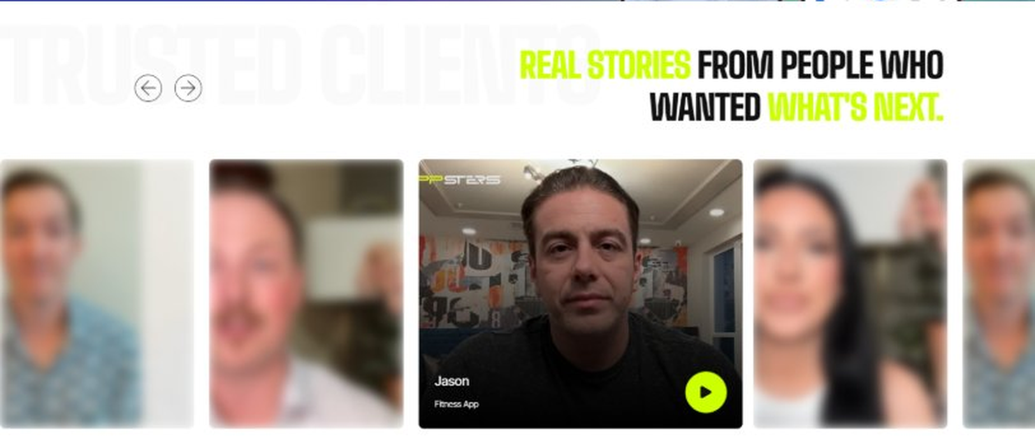
Current live page, www.appsters.io/industry
 | DETAIL
Status | New copy applied
Build Notes | Live block runs video testimonials. New copy is written quotes with attributions. Source document marks this fold design TBD.
Copy For This Fold
PAGE ELEMENT | COPY (WORD FOR WORD)
H2 (Section Heading) | What Our Clients Say
Testimonial 1 Quote | "We'd tried building this in-house for a year before bringing Appsters in. What they shipped in twelve weeks did more for our retention than our entire first year of internal development. That still stings a little, honestly, but I'm grateful for it."
Testimonial 1 Attribution | Jordan Ames, Founder
Testimonial 2 Quote | "The licensing piece was what scared us most going in. Every developer we talked to treated it as an afterthought. Appsters built the royalty logic first, before a single screen existed, and that decision saved us months of cleanup later."
Testimonial 2 Attribution | Renee Castillo, Head of Catalog Operations
Testimonial 3 Quote | “Our first festival weekend on the new app hit numbers we hadn't planned for. Nothing broke. The team who built it had clearly done this before, even under conditions that would rattle most agencies."
Testimonial 3 Attribution | Owen Baptiste, Director of Live Events
Testimonial 4 Quote | "I've worked with three different dev shops on music products. Appsters was the first one that asked about royalty splits before asking about the UI. That told me everything I needed to know."
Testimonial 4 Attribution | Simone Achebe, Label Operations Manager
Testimonial 5 Quote | "What sold me wasn't the pitch, it was watching them handle a scope change two weeks before launch without blinking. The app shipped on time and the fans noticed the difference immediately."
Testimonial 5 Attribution | Colin Marsh, Chief Product Officer
Source document note: Testimonial fold, design TBD after content
FOLD 8: Technology Logo Strip
Technology Logo Strip

Current live page, www.appsters.io/industry
 | DETAIL
Status | No copy change
Build Notes | No new copy in the source document for this fold. Keep the live block exactly as it is.
FOLD 9: Why Choose Us
Why Choose Us: Compelling Reasons To Choose Us As A Trustable App Development Company In Houston
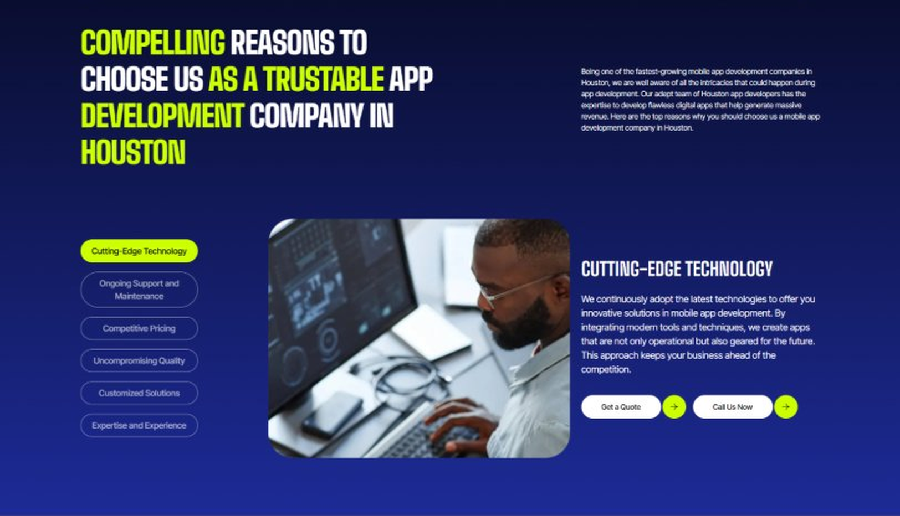
Current live page, www.appsters.io/industry
 | DETAIL
Status | New copy applied
Build Notes | Live block holds 6 tabs. New copy holds 6 reasons. Clean one to one fit, no design change needed.
Copy For This Fold
PAGE ELEMENT | COPY (WORD FOR WORD)
H2 (Section Heading) | Why Artists And Labels Choose Appsters As Their Trusted Music App Partner
Body Copy | Choosing a music app development partner shapes whether your platform survives past its first playlist push. Our team blends product thinking, engineering discipline, and licensing expertise to build apps that retain listeners, not just acquire downloads.
Reason 1 Heading | Playback-First Architecture
Reason 1 Copy | We design every feature around uninterrupted listening, backed by real streaming performance data rather than assumptions.
Reason 2 Heading | Built-In Licensing Logic
Reason 2 Copy | Rights management isn't bolted on later. Our systems check licensing and royalty splits automatically from the first upload.
Reason 3 Heading | Festival-Load Engineering
Reason 3 Copy | Our architecture is stress-tested for festival weekends and album drop nights, so a traffic spike becomes a good problem, not an outage.
Reason 4 Heading | Artist Monetization Built In
Reason 4 Copy | From tipping to subscriptions to merch drops, we design monetization tools that keep artists earning directly from their most loyal fans.
Reason 5 Heading | Transparent Development Cycles
Reason 5 Copy | We follow sprint cadences with review checkpoints and shared roadmaps, so clients always know what's shipping and what's improving.
Reason 6 Heading | Long-Term Platform Thinking
Reason 6 Copy | We structure apps as ecosystems that evolve with catalog growth and listener behavior, built for longevity rather than a single release cycle.
FOLD 10: Sector Tabs
Sector Tabs: Serving 40+ Sectors With Mobile App Development In Houston
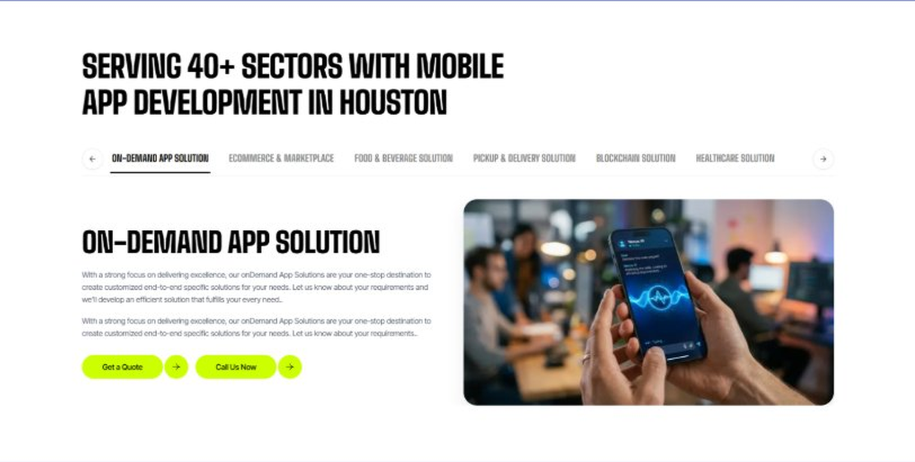
Current live page, www.appsters.io/industry
 | DETAIL
Status | New copy applied
Build Notes | Live block holds 6 sector tabs. New copy holds 5 solutions. Drop one tab or brief a sixth solution.
Copy For This Fold
PAGE ELEMENT | COPY (WORD FOR WORD)
H2 (Section Heading) | Music App Solutions Built For Every Stage Of The Listener Journey
Body Copy | Appsters delivers Music app solutions that cover everything from festival operations to artist monetization tools. Our systems are architected by senior Music app developers who focus on playback reliability, licensing accuracy, and stable performance. Through our Music app development services, we help organizations build platforms that feel premium, relevant, and built to scale with a growing catalog.
Solution 1 Heading | Event Management Apps
Solution 1 Copy | Our event management tools help festivals and venues coordinate lineups, staff schedules, and vendor logistics from one dashboard, with fan-facing schedules that update the moment something changes.
Solution 2 Heading | Corporate Events Apps
Solution 2 Copy | We build private event apps for label showcases, artist meet-and-greets, and industry conferences, giving organizers RSVP tracking and content sharing without leaning on generic event platforms.
Solution 3 Heading | Subscription-Based Meal Apps
Solution 3 Copy | For festivals running food programs across multiple stages, we build subscription-style meal pass systems that let fans prepay for a weekend of food without juggling cash or standing in separate lines at every vendor.
Solution 4 Heading | Cloud Kitchen Apps
Solution 4 Copy | We connect cloud kitchen operations to venue apps so promoters can run pop-up food concepts tied to a specific tour or festival, with orders routed straight to the closest prep station.
Solution 5 Heading | Inventory Management Apps
Solution 5 Copy | Behind every merch table and food stall sits real inventory. We build inventory management tools that keep tour merch, festival concessions, and limited drops accurate in real time, so nothing sells out without the app knowing.
FOLD 11: Engagement Models Table
Engagement Models Table: Flexible Engagement Models For Any App Development Need
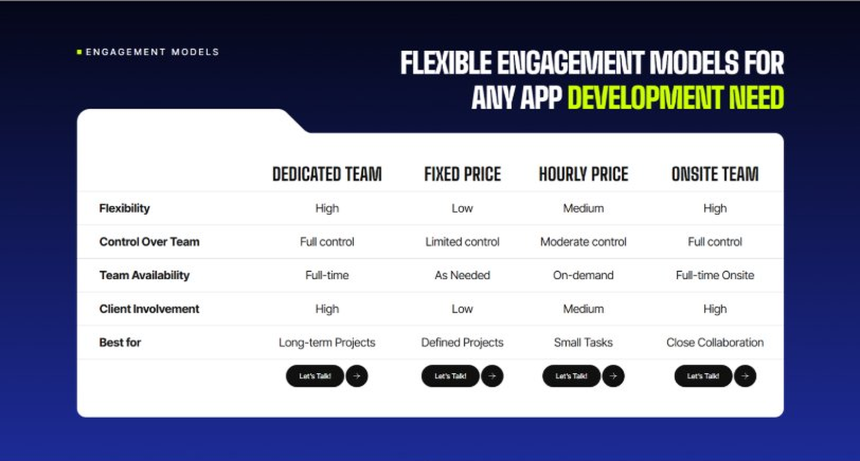
Current live page, www.appsters.io/industry
 | DETAIL
Status | No copy change
Build Notes | No new copy in the source document for this fold. Keep the live block exactly as it is.
FOLD 12: Game App CTA
Game App CTA: Into Engaging Mobile Games
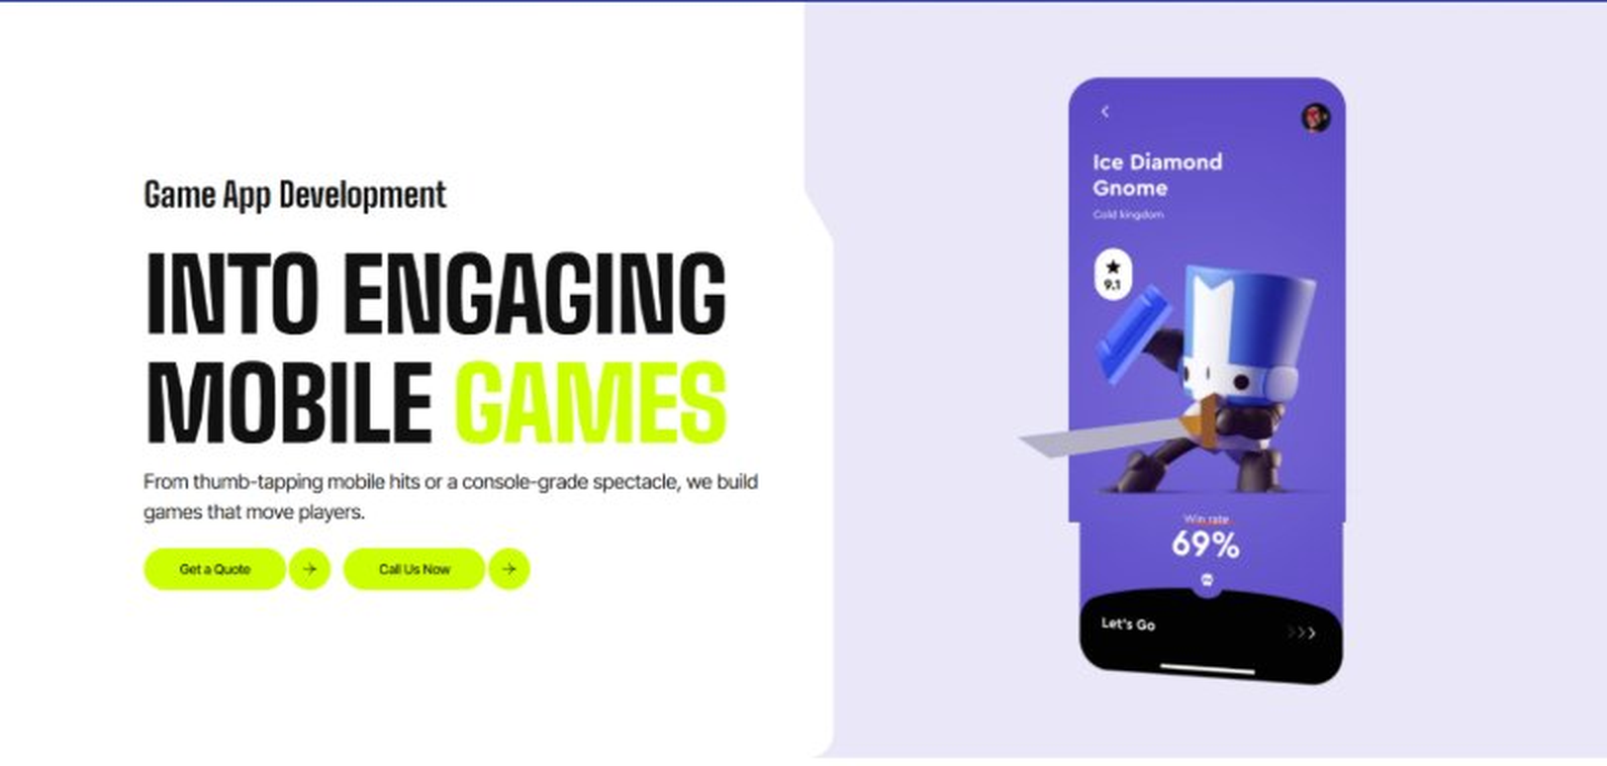
Current live page, www.appsters.io/industry
 | DETAIL
Status | No copy change
Build Notes | No new copy in the source document for this fold. Keep the live block exactly as it is.
FOLD 13: Collaboration And Client Logos
Collaboration And Client Logos
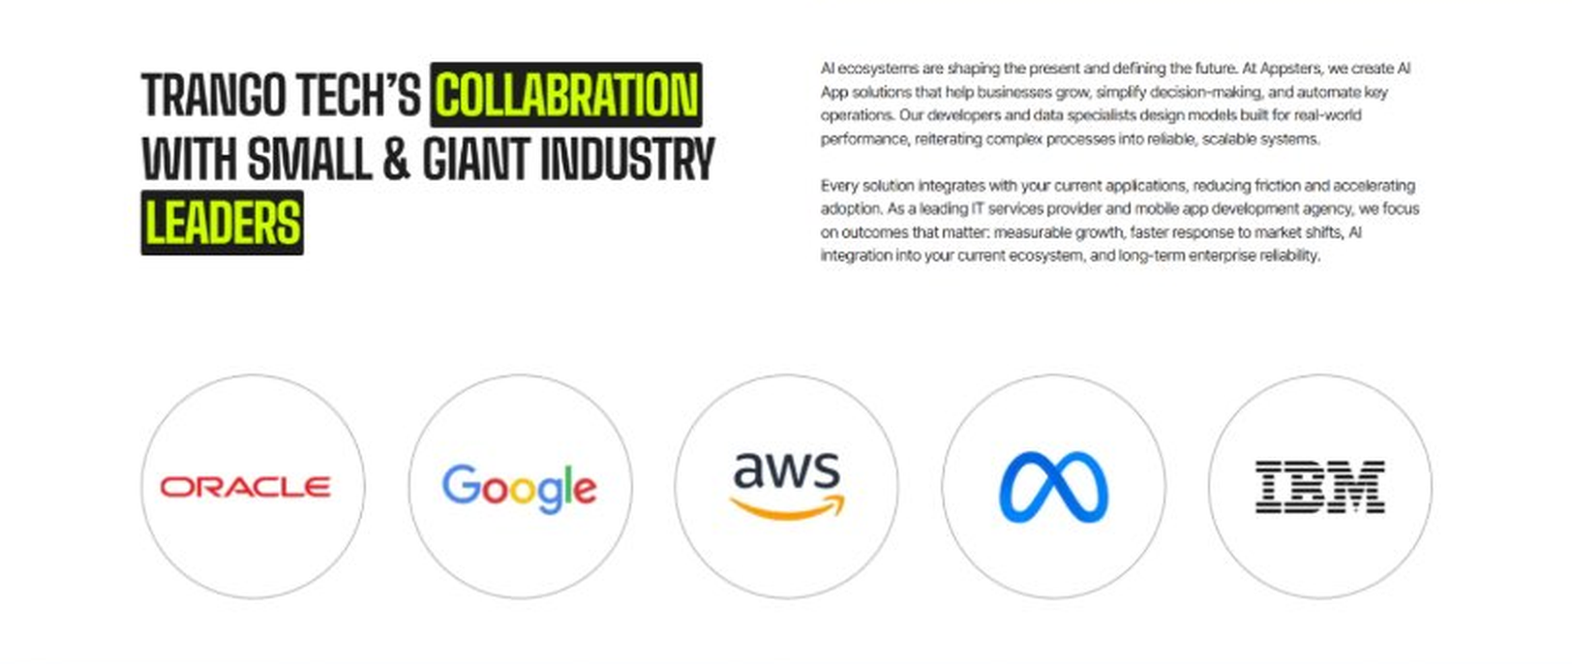
Current live page, www.appsters.io/industry
 | DETAIL
Status | No copy change
Build Notes | No new copy in the source document for this fold. Keep the live block exactly as it is.
QA Flag | Live heading reads "Trango Tech’s Collabration with Small & Giant Industry Leaders". That is a competitor name plus a spelling error sitting live on the page. Fix regardless of this content drop.
FOLD 14: Recognition CTA Banner
Recognition CTA Banner
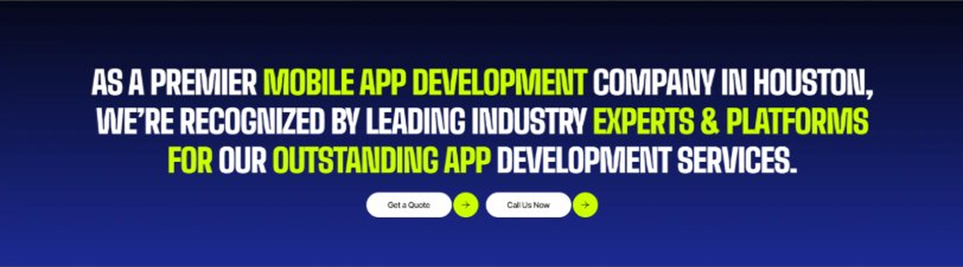
Current live page, www.appsters.io/industry
 | DETAIL
Status | New copy applied
Build Notes | Live block holds a headline and two CTA buttons. New copy supplies the heading and paragraph.
Copy For This Fold
PAGE ELEMENT | COPY (WORD FOR WORD)
H2 (Section Heading) | The Next Track Is Already Loading. Is Your Platform Ready To Launch?
Body Copy | Every day you wait is a day another app is competing for your listeners' attention. Let's build a Music app that keeps them streaming and coming back. Talk to Appsters today, and let's figure out what your first release actually needs to look like.
FOLD 15: Market Presence And Office Map
Market Presence And Office Map: Expand Your Market Presence
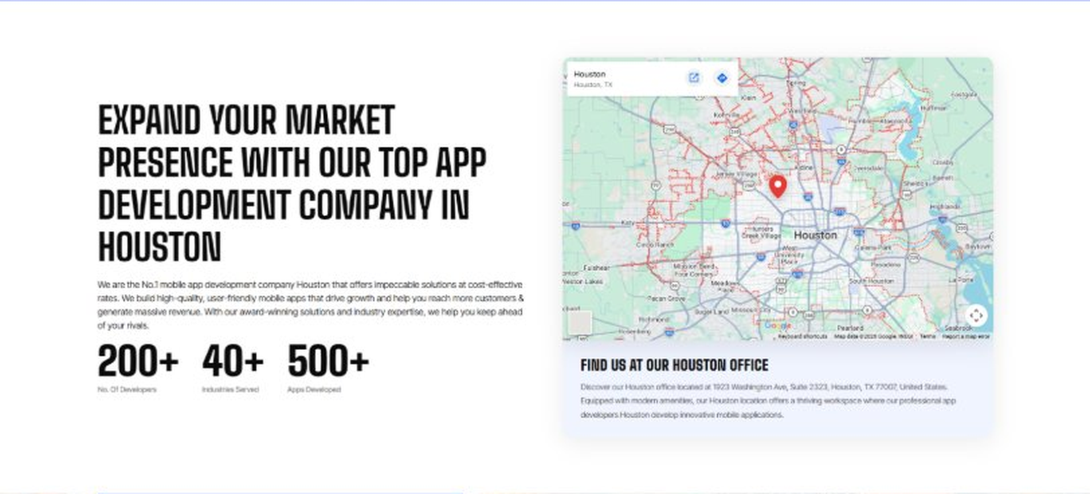
Current live page, www.appsters.io/industry
 | DETAIL
Status | New copy applied
Build Notes | Live block holds a heading, a paragraph, three counters and the office map. New copy supplies the heading and paragraph.
Copy For This Fold
PAGE ELEMENT | COPY (WORD FOR WORD)
H2 (Section Heading) | Food Ordering App Development Company Expertise Behind Every Music Platform We Build
Body Copy | As a team that knows how to develop mobile Music apps at scale, we bring the same rigor to embedded commerce and live-event features. Our engineers have shipped AI-based food delivery apps, ticketing systems, and merch platforms, giving us a deeper bench than studios that only build streaming interfaces. React Native, Swift, Kotlin, Node.js, and adaptive audio-streaming protocols form our core stack, paired with AI models tuned for recommendation, licensing checks, and fraud detection. Where most competitors treat commerce as a bolt-on, we design it into the core experience from day one.
FOLD 16: Portfolio
Portfolio: Quick Glimpse On Our Portfolio

Current live page, www.appsters.io/industry
 | DETAIL
Status | New copy applied
Build Notes | Live block holds a heading, a paragraph and one CTA. New copy holds an intro plus 4 named product cards. Source document marks this fold design TBD.
Copy For This Fold
PAGE ELEMENT | COPY (WORD FOR WORD)
H2 (Section Heading) | Music Products Engineered For Long-Term Listener Retention
Body Copy | Appsters builds music platforms that behave like long-term ecosystems, not one-album wonders. Our solutions stand out because they blend audio engineering, licensing logic, and behavioral analytics in one stable system. Every product is architected for retention, discovery, and real connection between artists and fans.
Product 1 Heading | TrackWave
Product 1 Copy | TrackWave is a streaming app built for independent artists who got tired of algorithms burying their new releases. Direct fan messaging, transparent royalty dashboards, and adaptive audio quality keep both artists and listeners engaged. The backend handles catalog licensing checks automatically, so uploads clear review in minutes, not weeks.
Product 2 Heading | SetlistHub
Product 2 Copy | SetlistHub is a live-event companion app that syncs setlists, merch drops, and food ordering to what's actually happening on stage in real time. Fans get push alerts the moment their favorite song starts, along with quick links to grab a drink before the encore.
Product 3 Heading | FanForge
Product 3 Copy | FanForge is a fan community and monetization app that lets artists sell exclusive content, host listening parties, and run subscription tiers without relying on a label's infrastructure. Payout tracking stays transparent down to the individual stream.
Product 4 Heading | StageSync
Product 4 Copy | StageSync is a festival operations app that gives promoters a single dashboard for lineup changes, vendor coordination, and crowd density alerts, while fans get a clean interface for schedules, maps, and mobile ordering.
Source document note: Portfolio fold, design TBD after content
FOLD 17: Tech Stack Tabs
Tech Stack Tabs: Mobile App Development, A Tech Stack For The Bold
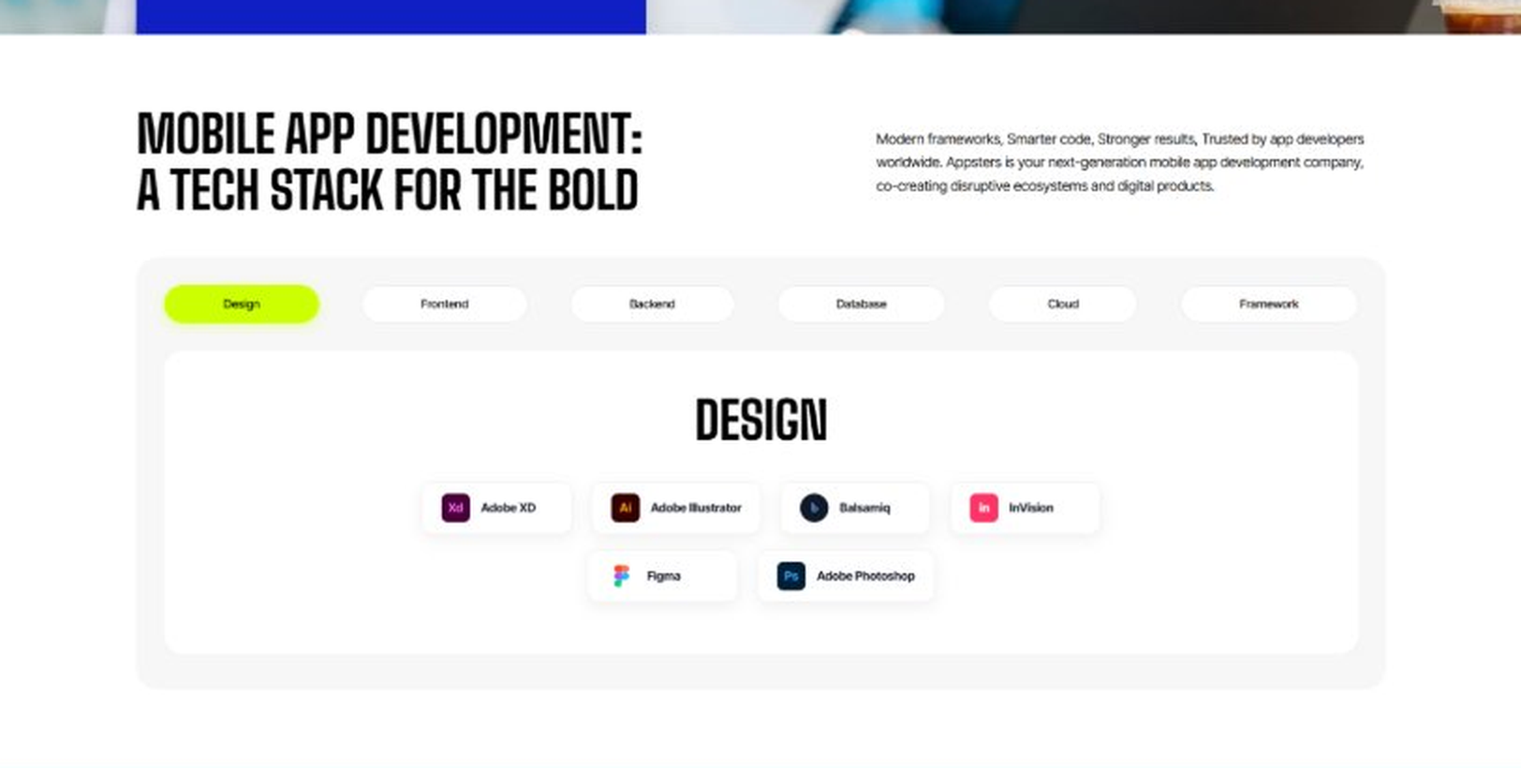
Current live page, www.appsters.io/industry
 | DETAIL
Status | New copy applied
Build Notes | Live block holds 6 category tabs with tool logos. New copy supplies the heading and paragraph, the tab contents stay as they are.
Copy For This Fold
PAGE ELEMENT | COPY (WORD FOR WORD)
H2 (Section Heading) | Technology Stack That Powers High-Performance Music Applications
Body Copy | Our engineering foundation supports gapless streaming, heavy audio traffic, and platform-wide scalability. Through our Music application development services, we use Swift, Kotlin, Flutter, React Native, Node.js, adaptive bitrate streaming protocols, and secure cloud infrastructure alongside AI-driven recommendation engines. Every stack decision reinforces speed, reliability, and long-term flexibility so your platform can grow without a rebuild, whether growth comes from steady catalog expansion or one song going viral overnight.
FOLD 18: Process
Process: App Development Process
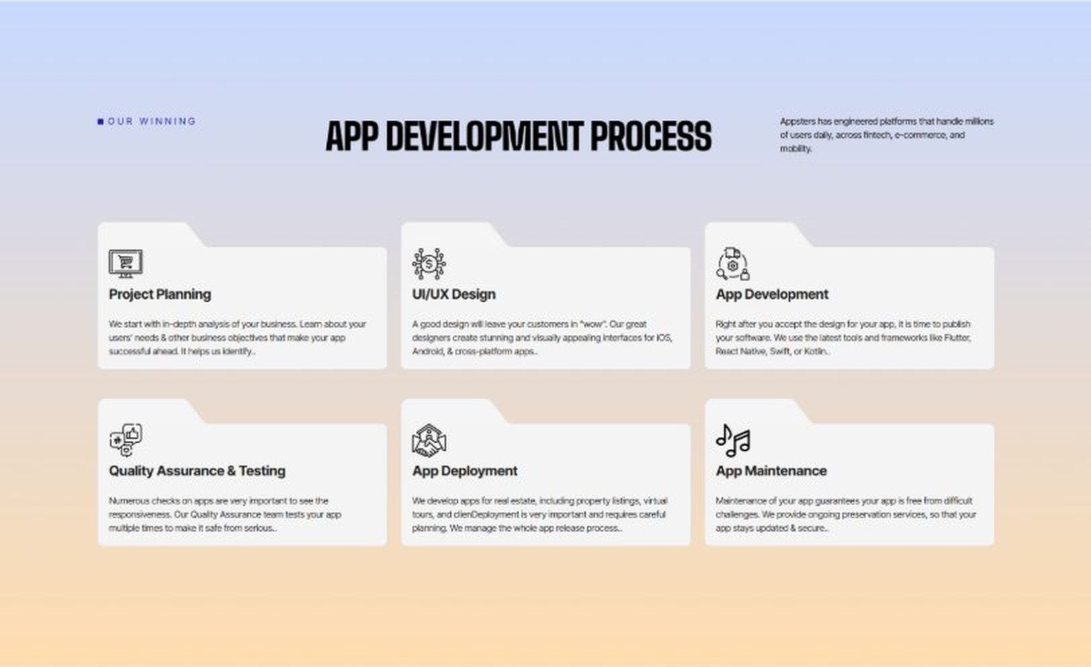
Current live page, www.appsters.io/industry
 | DETAIL
Status | New copy applied
Build Notes | Live block holds 6 step cards. New copy holds 8 steps. Either widen the block to 8 or merge two steps.
Copy For This Fold
PAGE ELEMENT | COPY (WORD FOR WORD)
H2 (Section Heading) | Music App Development Process Built For Platforms That Actually Ship
Body Copy | A music platform needs more than good sound quality. It needs structure, clarity, and a process engineered for licensing, scale, and retention from day one. Our Music app development process aligns product goals with technical roadmaps so every phase moves with intention.
Step 1 Heading | App Idea & Research
Step 1 Copy | Every project begins with structured discovery, where our teams map listener behavior, licensing requirements, catalog structure, and monetization models. We benchmark engagement patterns across existing platforms and define what will make your app worth opening every day. By the time research closes, the product's purpose, risks, and growth path are already clear.
Step 2 Heading | Strategic Planning & Consultation
Step 2 Copy | Here we translate research into a measurable plan. Our strategists define the technical architecture, licensing workflows, monetization strategy, and delivery milestones needed to build your AI Music mobile app the right way, from the first sprint.
Step 3 Heading | Wireframing & Prototyping
Step 3 Copy | We turn ideas into tangible user journeys. Wireframes capture navigation, playback controls, and discovery flow in a visual structure stakeholders can react to before a single line of code gets written. Every screen gets tested against real listening habits.
Step 4 Heading | App Development
Step 4 Copy | This is where engineering takes over. Our developers implement streaming infrastructure, recommendation engines, licensing checks, and monetization features with the same discipline a food app development company applies to order accuracy and uptime. Development stays sprint-driven and transparent throughout.
Step 5 Heading | Expert QA & Testing
Step 5 Copy | Quality assurance covers far more than bug hunting. We validate playback under network stress, licensing accuracy, cross-device behavior, and payment reliability. Only stable, predictable behavior earns approval to move forward.
Step 6 Heading | App Launch
Step 6 Copy | Launch is a coordinated rollout, not a leap of faith. We manage store compliance, metadata strategy, onboarding polish, and final performance checks so your platform enters the market ready to hold real listener traffic.
Step 7 Heading | Deployment
Step 7 Copy | Our deployment pipelines are built for consistency and safety. We configure cloud infrastructure, optimize CDNs for audio delivery, and calibrate autoscaling so your app performs the same for 10,000 listeners as it does for 10 million.
Step 8 Heading | Maintenance & Support
Step 8 Copy | Post-launch, we keep monitoring listening patterns, refining recommendation logic, patching vulnerabilities, and responding to new licensing or app store requirements, so your catalog keeps growing long after day one.
Source document note: Process fold, design TBD after content
FOLD 19: Blog Posts
Blog Posts: Our Related Blog Posts
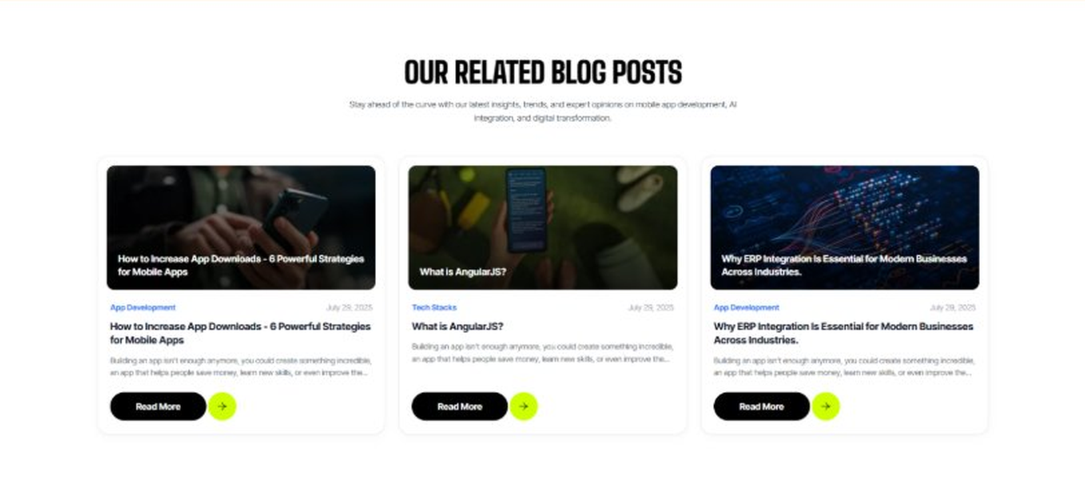
Current live page, www.appsters.io/industry
 | DETAIL
Status | No copy change
Build Notes | No new copy in the source document for this fold. Keep the live block exactly as it is.
FOLD 20: FAQs
FAQs: Your Questions, Our Clarity
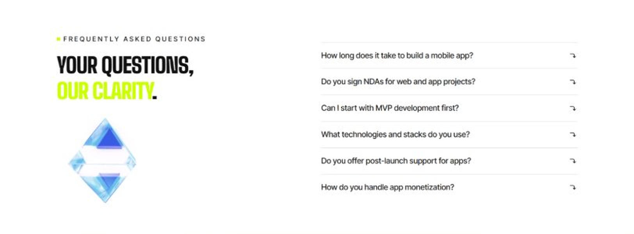
Current live page, www.appsters.io/industry
 | DETAIL
Status | New copy applied
Build Notes | Live block holds 6 accordion rows. New copy holds 6 questions and answers. Clean one to one fit.
Copy For This Fold
PAGE ELEMENT | COPY (WORD FOR WORD)
H2 (Section Heading) | Frequently Asked Questions
FAQ 1 Question | How long does it typically take to build a fully functional music app?
FAQ 1 Answer | Timelines depend on catalog size, licensing complexity, and streaming infrastructure needs. Most projects take 12 to 20 weeks for a stable release, including design, engineering, QA, and beta testing. As a music app development company, we provide clear milestones from day one.
FAQ 2 Question | Can Appsters build an AI Music app with smart recommendations?
FAQ 2 Answer | Yes. We build AI Music apps with recommendation engines, mood-based discovery, and automated playlist generation baked into the core architecture, not added as an afterthought.
FAQ 3 Question | Do you support in-app commerce features as a food delivery app development company would?
FAQ 3 Answer | Absolutely. Many of our Music app developers have direct experience building commerce and delivery flows for live events, so we can embed ordering, ticketing, and merch sales directly into your platform.
FAQ 4 Question | What makes Appsters different from other Music mobile app development company options?
FAQ 4 Answer | We treat licensing accuracy, playback reliability, and monetization as core product decisions, not add-ons. Most Music app development companies focus on UI first and scale later. We do both from the start.
FAQ 5 Question | Can you handle sudden traffic spikes during festival season or a big album drop?
FAQ 5 Answer | Yes. Our architecture is stress-tested for exactly this kind of load, so a surge in listeners becomes a growth milestone instead of a downtime incident.
FAQ 6 Question | What ongoing support do you provide after launch?
FAQ 6 Answer | Our Music app development services include post-launch monitoring, feature updates, licensing checks, and infrastructure scaling, so your platform keeps improving long after release.
FOLD 21: Locations
Locations: Our Global Presence
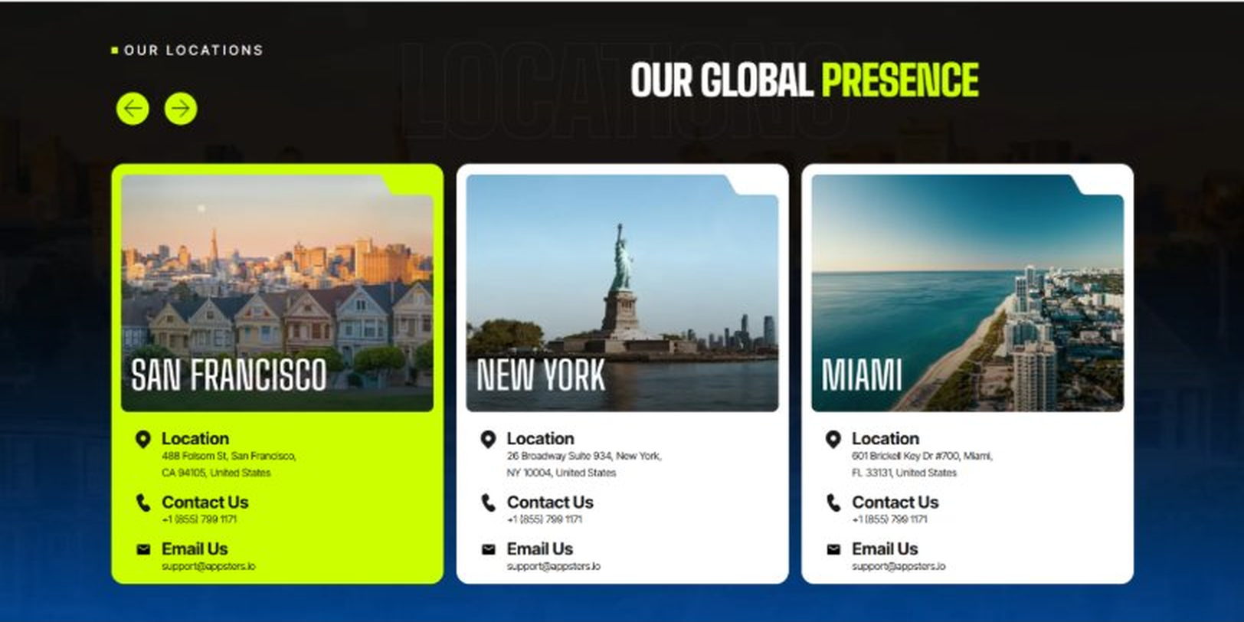
Current live page, www.appsters.io/industry
 | DETAIL
Status | No copy change
Build Notes | No new copy in the source document for this fold. Keep the live block exactly as it is.
FOLD 22: Contact Form
Contact Form: Connect With Us
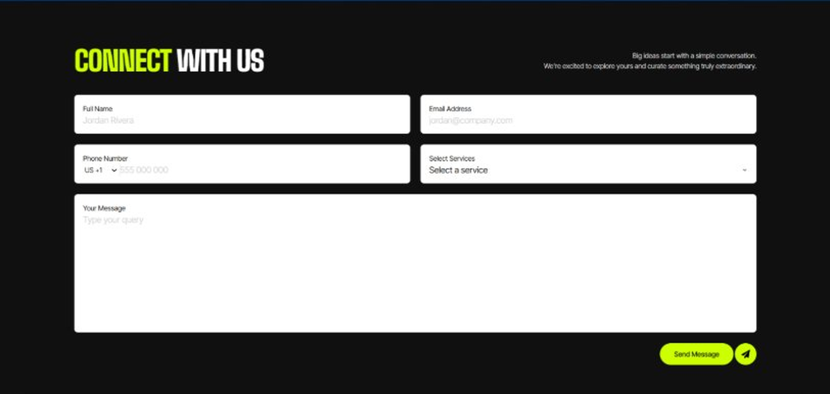
Current live page, www.appsters.io/industry
 | DETAIL
Status | No copy change
Build Notes | No new copy in the source document for this fold. Keep the live block exactly as it is.
FOLD 23: Footer
Footer
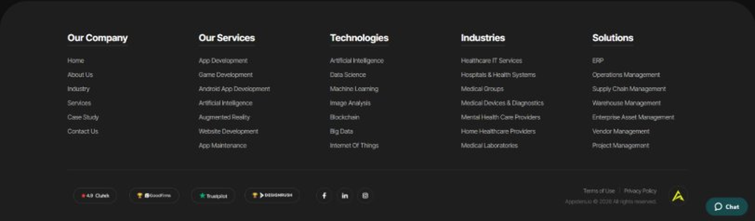
Current live page, www.appsters.io/industry
 | DETAIL
Status | No copy change
Build Notes | No new copy in the source document for this fold. Keep the live block exactly as it is.
NEW BLOCKS REQUIRED
The three blocks below are in the source content but have no matching section anywhere on the current /industry page. Each one needs a new block built.
NEW BLOCK: Distinct Features That Set Our Music Apps Apart
 | DETAIL
Status | No equivalent block on the live page
Placement | Suggested placement: directly after Fold 5, reusing the services card grid styling.
Copy For This Block
PAGE ELEMENT | COPY (WORD FOR WORD)
H2 (Section Heading) | Distinct Features That Set Our Music Apps Apart
Feature 1 Heading | Dashboard & Admin Panel
Feature 1 Copy | A centralized control center gives your team visibility into streaming activity, catalog health, and royalty accuracy without digging through raw data.
Feature 2 Heading | Push Notifications
Feature 2 Copy | Smart, behavior-based notifications alert fans to new releases and ticket drops at the right moment instead of burying them in noise.
Feature 3 Heading | Digital Menu
Feature 3 Copy | A structured, browsable content menu lets listeners navigate genres, playlists, and artist collections without losing their place mid-session.
Feature 4 Heading | Order Tracking
Feature 4 Copy | For platforms with in-app commerce, real-time order tracking keeps fans informed on merch and food orders without pulling them out of the show.
Feature 5 Heading | Social Media Integration
Feature 5 Copy | Direct sharing to existing social platforms lets fans post what they're listening to and drive discovery straight from their own networks.
NEW BLOCK: Industries We Serve
 | DETAIL
Status | No equivalent block on the live page
Placement | Suggested placement: directly after Fold 10, as a card grid rather than tabs.
Copy For This Block
PAGE ELEMENT | COPY (WORD FOR WORD)
H2 (Section Heading) | Industries We Serve
Body Copy | One Codebase. Infinite Industries. Our web, app, and AI solutions are built to perform, scale, and adapt while setting industry standards and redefining what's possible for businesses everywhere.
Industry 1 Heading | Fintech
Industry 1 Copy | We co-create secure, compliant fintech apps that simplify payments, investments, and trading, using the same real-time transaction infrastructure we build for ticketing and merch inside music platforms.
Industry 2 Heading | Healthcare
Industry 2 Copy | We develop HIPAA-compliant healthcare apps that bridge doctors, patients, and data, applying the same low-latency streaming expertise we use for live audio and video.
Industry 3 Heading | Education
Industry 3 Copy | Our education apps gamify learning and power virtual classrooms, borrowing engagement and content-recommendation logic straight from music discovery engines.
Industry 4 Heading | Real Estate
Industry 4 Copy | We design real estate apps that help buyers, sellers, and agents close deals faster, with media-rich listings built on the same streaming infrastructure that powers our music platforms.
Industry 5 Heading | Automotive
Industry 5 Copy | From fleet dashboards to in-car entertainment integrations, we digitize automotive operations with the same audio streaming expertise behind our music apps.
Industry 6 Heading | Social Media
Industry 6 Copy | We build social platforms that are scalable and sticky, often integrating music discovery and sharing features straight from our own streaming stack.
Industry 7 Heading | Logistics
Industry 7 Copy | We power logistics apps with route optimization and real-time tracking, using the same live-notification infrastructure that keeps concert and festival apps instant.
Industry 8 Heading | Ecommerce
Industry 8 Copy | We build ecommerce apps with frictionless checkouts and AI product recommendations, drawing on the same recommendation engines we use to match listeners with new music.
NEW BLOCK: Advanced Technologies That Power Our Music Apps
 | DETAIL
Status | No equivalent block on the live page
Placement | Suggested placement: directly after Fold 17, reusing the services card grid styling.
Copy For This Block
PAGE ELEMENT | COPY (WORD FOR WORD)
H2 (Section Heading) | Advanced Technologies That Power Our Music Apps
Body Copy | As a music app development company built around what's next, we don't stop at streaming and playlists. Every music app developer on our team stays current with tools that keep platforms competitive, from AI recommendations to live commerce. Unlike most music app development companies still catching up on food ordering app development trends inside live-event apps, we're already building AI-based music apps with these capabilities baked in.
Technology 1 Heading | AI-Integrated Music Apps
Technology 1 Copy | We build AI Integrated Music Apps with smart recommendation engines, mood detection, and automated playlist generation, giving listeners a feed that actually understands their taste.
Technology 2 Heading | Payment Gateway Integration
Technology 2 Copy | Secure, PCI-compliant payment gateway integration lets your platform handle tipping, subscriptions, ticketing, and merch transactions without third-party friction.
Technology 3 Heading | Cloud Solutions
Technology 3 Copy | Our cloud solutions keep audio-heavy platforms fast and reliable, with autoscaling infrastructure built to absorb festival-weekend traffic spikes.
Technology 4 Heading | MVP For Music Apps
Technology 4 Copy | When you need to validate an idea fast, our MVP for Music Apps approach gets a functional, testable product into real listeners' hands without a twelve-month build cycle.
Technology 5 Heading | API Integration
Technology 5 Copy | We connect your platform to ticketing services, royalty databases, and other music ecosystems through clean, well-documented API integration.

